**end-User guide**

System Requirements

You may run the system windows interface application any OS including but not limited to Windows 10 and Windows 8 OS. The system must have SQL Server database installed to allow for connecting to the AskAMech database. You can connect using any browser such as Firefox, Chrome, Microsoft Edge.

Access to the windows application

Any user having the application executable and meeting the system requirements stipulated above can access the windows interface application. And also, any user having internet connection and using one the listed browsers can access the web interface application using the following link: <http://askamech.com>

[Login]

Access to the application is not restricted and any user can gain access to the application. Without authorization the unauthorized user can view questions and their answers, and also view user profiles. authorized users can see the latter and also have other capabilities. each user should know his user name and password to be able to ask questions and answer questions.

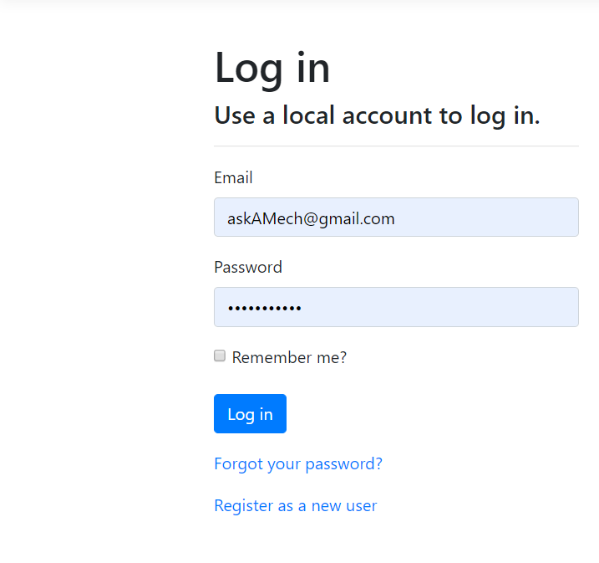

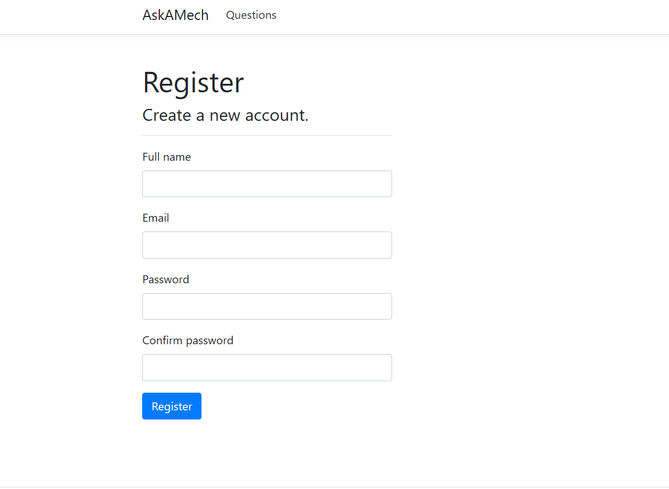

Application Main Page

After opening the application, the page below is displayed. The user can use this screen view questions. For any user (authorized or not authorized). By default, the questions page. Each question title is a link to the question and its answers.

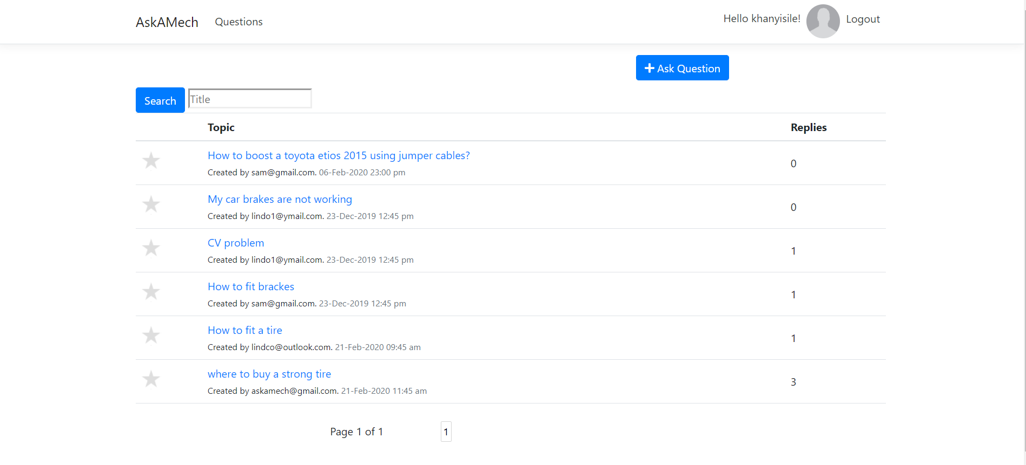

Question and its answers

By clicking on the question, the link shows you a screen with the details of the question and also all the answers that belong to that question. You can add answer to the question and view user profile by clicking on the username link.

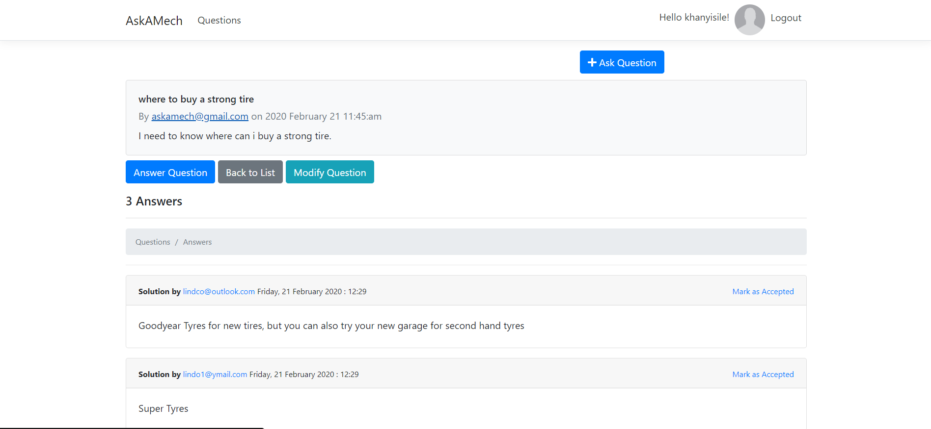

* You can provide the answer by clicking on the answer button or scroll to the bottom.
* If you are an author of the question you have ability to mark answer as accepted.
* The author of the question can modify the question.

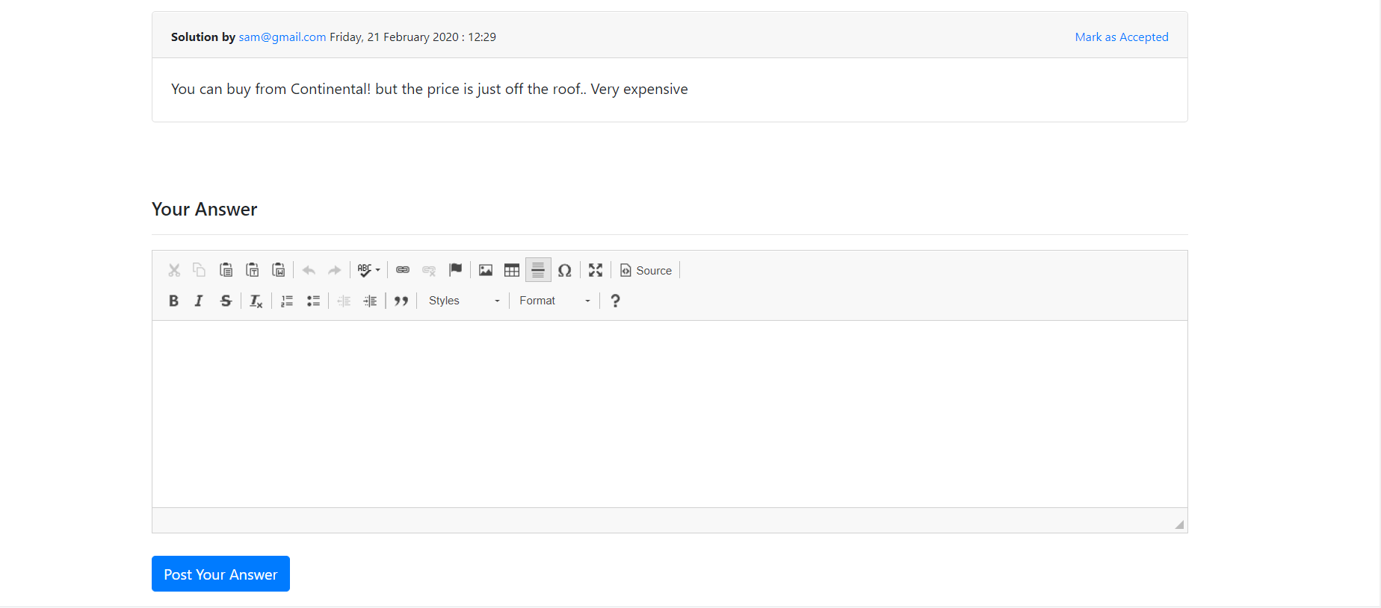

Modify question

* Click on the modify button

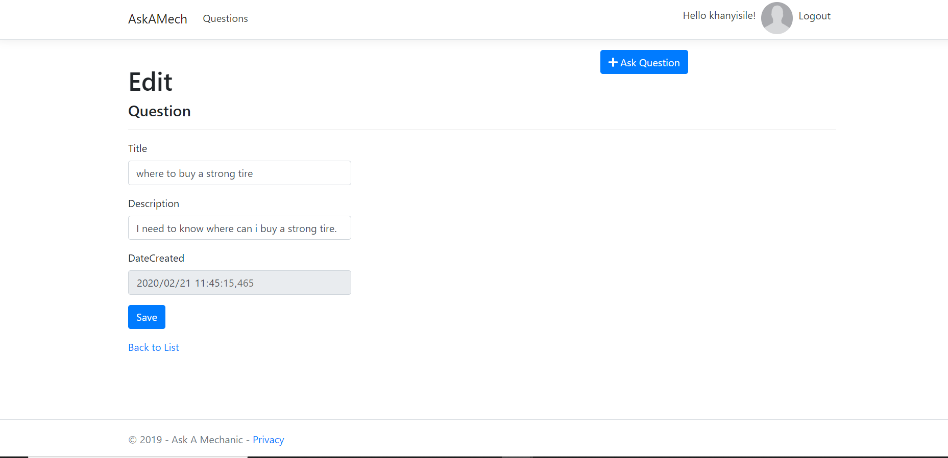

* If you are not the author of the question, you cannot mark an answer as accepted hence the link will not show.
* You cannot also modify the question.
* The actions are hidden.

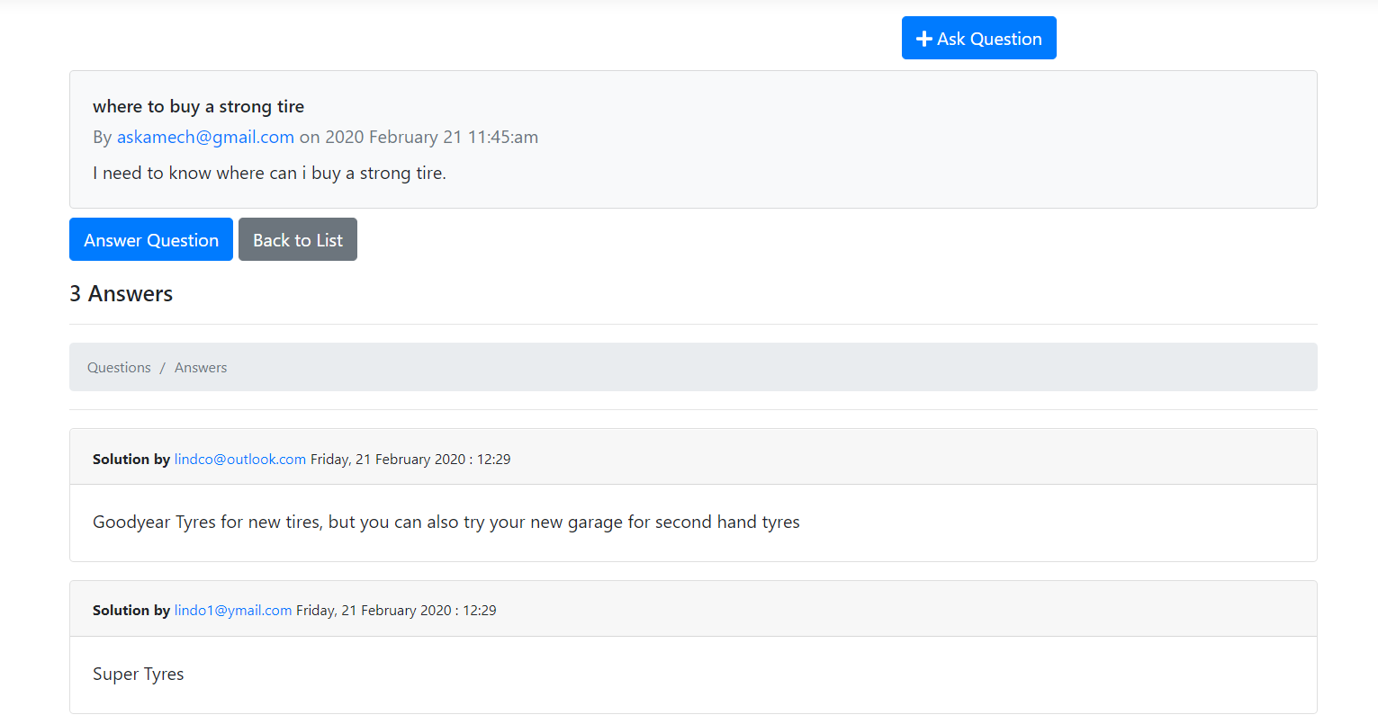

Answer Question

* Click on the answer question. It will take you to the following screen.
* Click on create button

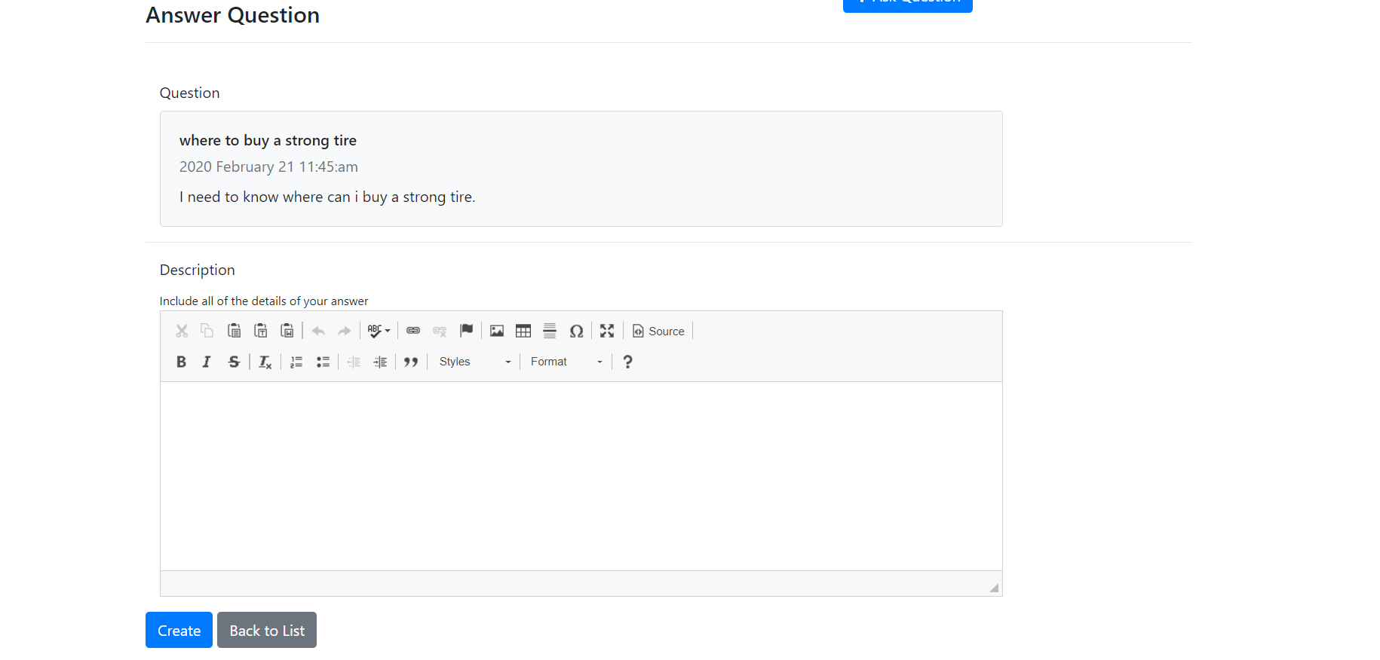

View user profile

Click on the username link next to date

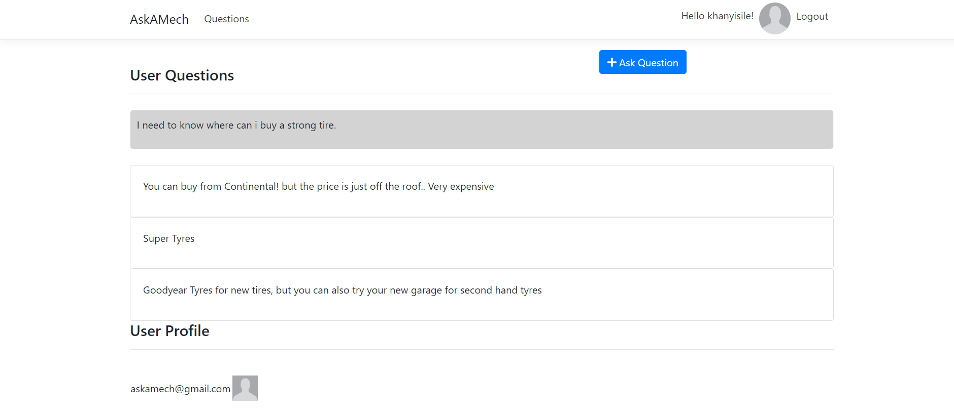

* This shows the userprofile with questions and answers provided by the user.
* Unauthorized user can view questions and answers but cannot mark answer as accepted or modify the answer

